|  |  |
| --- | --- |
|  | **2015** |
|  | INVENTRUST |

|  |
| --- |
| **OPHTHALMIC SURGERIES** |
| PATENT INTELLIGENCE REPORT for 2015 by |

*Disclaimer*

*Entire contents ©2015 InvenIt Inc. All rights reserved. Reproduction of this publication in any form without prior written permission is forbidden. The information contained herein has been obtained from data sources believed to be reliable. InventIt disclaims all warranties as to the accuracy, completeness or adequacy of such information. The results identified are only up to the date specified in this document. No opinion, unless clearly stated otherwise, is expressed or implied other than the comments stated herein. InventIt is not a law firm and does not provide any legal advice or legal opinion.*

**CONTENTS**

**Introduction**

**Patenting Activity Trends**

**Leading Companies**

**Publication Trends of Leading Companies**

**Priority Countries**

**Worldwide Geographical Coverage**

**Prolific Inventors – Overall in the Cluster**

**Prolific Inventors at leading companies**

**Most Cited Patents**

## **Introduction**

**Welcome to the 2015 ‘Ophthalmic Surgeries’ Intelligence report!**

This report discusses advancements and patenting activity in the area of surgical devices, apparatuses and procedures employed in ophthalmology. With a rising geriatric population across the world, there is going to be an increase in the demand for advanced ophthalmic procedures and devices, giving an overall boost to the growth of this industry. The increased demand for improved ophthalmic devices and procedures will also be aided by the fact that worldwide population of young and old alike are becoming extensive users of computer aided devices and smartphones which imminently cause dryness of eyes and several other related disorders. Further with the existing medical devices and implants in the ophthalmology industry becoming obsolete, increased acceptance for latest procedures and devices by the population worldwide, and better medical reimbursement facilities being made available to people worldwide (particularly in the US), this industry is poised for a rapid technological growth. The entire market is segmented in major disciplines such as cataract eye surgeries, refractive surgeries, vitreo retinal surgeries, glaucoma surgeries etc.

With the introduction of advanced and minimally invasive technology in ophthalmic devices, people are opting for ophthalmic surgeries to correct eye disorders. Newly developed minimally invasive laser technologies are fuelling the growth in surgeries. The global ophthalmic devices market is expected to register a compounded annual growth rate of approximately 4% during 2011 to 2017 according to Transparency Market Research Report.

Alcon, Bausch & Lomb, Zeiss, Wavelight AG, Nidek, and Federal Noe G Uchrezhdenie MNT are among the leading companies as far as patenting activity is concerned. United States, Japan, Australia, China, Russia, WIPO, and EPO are the major patenting routes and jurisdictions for patent rights protection in this cluster.

## **Patenting Activity Trends**

There has been a constant increase in patenting activity in the domain of ophthalmic surgeries, particularly since the decade of 1971-1980. In the decade 1971-1980, only 56 patent families were published. In the decade 2001-2010, a total of 1299 patent families were published. In only the last five years, 2011-2015, 1400+ patent families were published. Of these 1400+ patent families, 297 patent families were published in the year 2015 only.

The first few patents that are identified in this report were filed before the onset of the 20th century. Two patents were filed before the 20th century, one in the year 1899 and another in the year 1885. Both these patents seem to relate to surgical instruments for eye related operations. These are listed below.

British Patent GB189907501A filed in 1899 and entitled “Improvements in Surgical Instruments for Improving Eye-sight” was assigned to Stephens Benjamin Fredenburgh. The patent provides a surgical instrument for eyes.

US Patent 4726367 filed in 1885 and entitled “Surgical instrument for implanting an intraocular lens” was assigned to Shoemaker David W.

Recent filings relate to technologies such as methods or devices for eye surgery using laser as one important medium.

**Figure 1 - Patent Publishing Trends for Ophthalmic Surgeries**

**Figure 2 - Patent Filing Trends for Ophthalmic Surgeries**

**Figure 3 - Priority Trends for Ophthalmic Surgeries**

## **Leading Companies**

As noted in the graph, Alcon holds the most number of patent families with a total of 255 patent families in ophthalmic surgery domain. Compared to the overall portfolio in this technology cluster, Alcon’s holding represents 6.8%. Alcon is followed by Federal Noe G Uchrezhdenie MNT and Carl Zeiss with 149 and 124 patent families assigned to them respectively. Other major companies are Wavelight, Nidek, Bausch & Lomb, Abott Medical Optics, Visx, AMO Dev Inc etc.

Initial patents of Alcon were published in the 80s. Federal Noe G Uchrezhdenie MNT is a Russian organization which started filing patents around the year 2005. Carl Zeiss’s patent filing activity started in 1980s.

Analysis of recent patents in this technology reveals that the patents chiefly relate to laser eye surgery and its related tools and techniques, and to procedures and substances related to phacoemulsification.

**Figure 4 - Leading Companies**

|  |  |
| --- | --- |
| Assignees | Percentage of total Patent Families (%) |
| Alcon | 6.8 |
| Federal Noe G Uchrezhdenie MNT | 3.9 |
| Carl Zeiss | 3.3 |
| Wavelight | 2.4 |
| Nidek | 2.3 |

**Figure 5 – Top 5 Companies Percentage Holdings**

## **Publishing Trends of Leading Companies**

Figure 6A – Alcon

Figure 6C – Carl Zeiss

Figure 6B – Federal Noe G Uchrezhdenie MNT

Figure 6D – Wavelight

Figure 6F – Bausch & Lomb

Figure 6E – Nidek

## **Priority Countries**

United States is ranked on top in conceptualization of ophthalmic surgical procedures and devices. As many as 2,416 patent families worldwide developed and originated from US. US is followed by WIPO and Russia, from where more than 688 and 400 patent families originated respectively.

Companies who have filed for patents that consider US as the priority country include such as Alcon, Bausch & Lomb, Abott Medical Optics, VISX Inc. etc.

Of the 400 patent families that originated from Russia, 149 belong to Federal Noe G Uchrezhdenie MNT, which is also one of the top patent filers. Almost 30% of the patent families that originated in Germany are owned by Carl Zeiss AG.

Figure 7 - Priority Countries for Ophthalmic Surgeries

## **Worldwide Geographical Coverage**

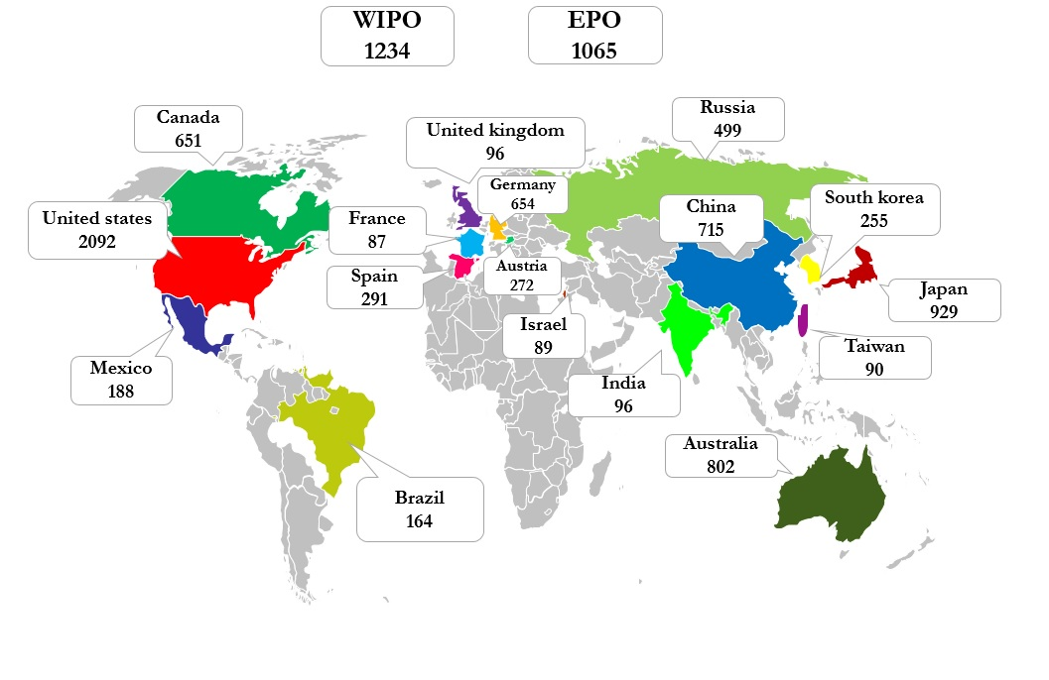

Figure 8 - Worldwide Patenting Activity

The global map (Figure 8) illustrates patenting activity worldwide across top 19 major jurisdictions. Numbers in the map represent unique patent families. United States leads other jurisdictions and is followed by WIPO and EPO.

Figure 9 below illustrates leading companies across major jurisdictions. Some of the companies that have actively filed patents in most of the key jurisdictions are Alcon, Bausch & Lomb, Zeiss, Visx. Wavelight etc. There is seen an increase in patenting activity in the recent years in the major jurisdictions.

**EPO**

**WIPO**

**EPO**

**WIPO**

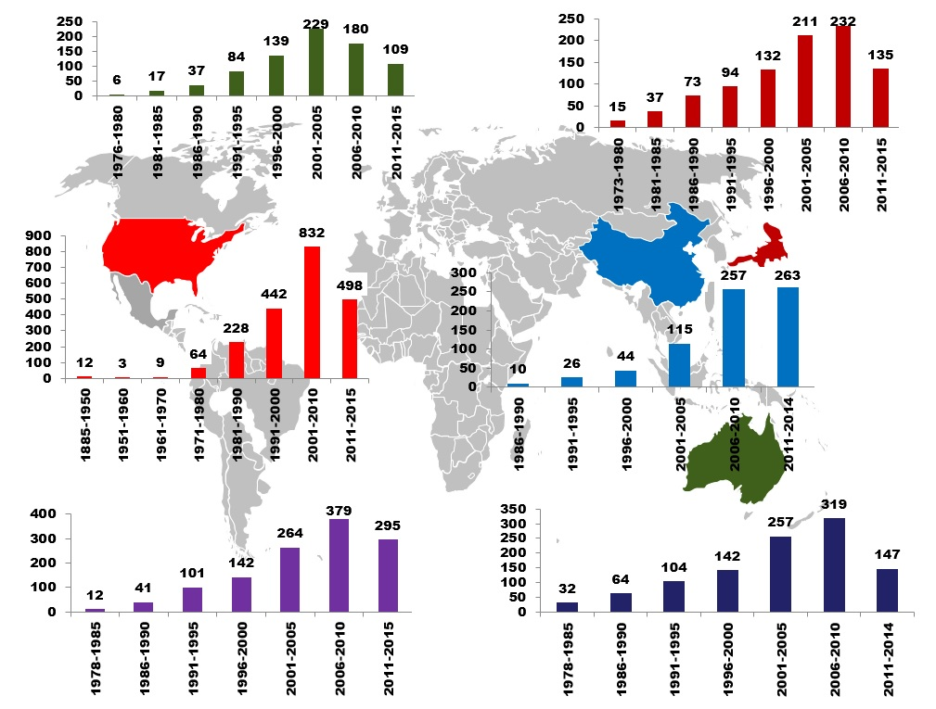

Figure 10 - Patent Filing Trends Across Key Jurisdictions

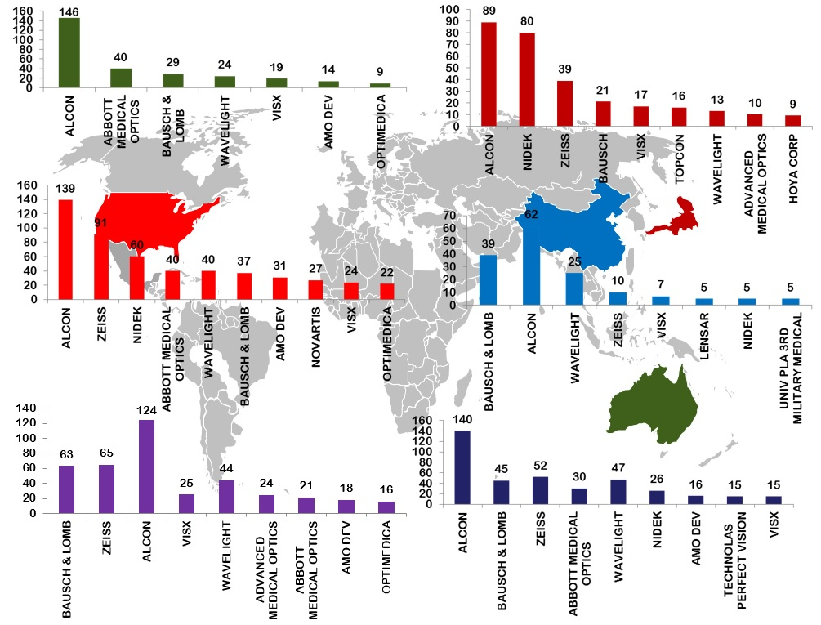

Figure 9 - Leading Companies Across Key Jurisdictions

## **Prolific Inventors – Overall**

The data shows that the most prolific inventor holds 64 patent families. The top inventor Donitzky,Christof works for Wavelight AG. Other prolific inventor, Takhchidi Khristo Periklovich holds 56 patent families, and works for Federal Noe G Uchrezhdenie MNT. Other prolific inventors follow with 40, 35, and 30, and 26 patent families. Several inventors have only one or two patents in their names. More than 5,000 inventors have contributed to the ophthalmic surgeries related patent portfolio.

Figure 11 - Prolific Inventors in Ophthalmic Surgeries

**Prolific Inventors at Leading Companies**

Figure 12a – Prolific Inventors at Alcon

Figure 12b – Prolific Inventors at Federal Noe g

Figure 12c - Prolific Inventors at Carl Zeiss

Figure 12d - Prolific Inventors at Wavelight

## **Most Cited Patents**

The following graph shows patent publications that are cited the most by other patent publications.

## 

Figure 13 - Most Cited Patent Publications

|  |  |  |  |  |
| --- | --- | --- | --- | --- |
| **Publication** | **Title** | **Assignee** | **Inventor** | **Application Year** |
| US3589363A | MATERIAL REMOVAL APPARATUS AND METHOD EMPLOYING HIGH FREQUENCY VIBRATIONS | CAVITRON CORP | BANKO, ANTON | KELMAN, CHARLES D. | 1967 |
| US6246898B1 | METHOD FOR CARRYING OUT A MEDICAL PROCEDURE USING A THREE-DIMENSIONAL TRACKING AND IMAGING SYSTEM | SONOMETRICS CORP | VESELY, IVAN | SMITH, WAYNE | KLEIN, GEORGE | BURKHOFF, DANIEL | 1998 |
| US5766016A | SURGICAL SIMULATOR AND METHOD FOR SIMULATING SURGICAL PROCEDURE | GEORGIA TECH RES INST | SINCLAIR, MICHAEL J. | PEIFER, JOHN W. | 1994 |
| US4863457A | DRUG DELIVERY DEVICE | LEE DAVID A | LEE, DAVID A. | 1988 |
| US4373218A | VARIABLE POWER INTRAOCULAR LENS AND METHOD OF IMPLANTING INTO THE POSTERIOR CHAMBER | SCHACHAR RONALD A | SCHACHAR, RONALD A. | 1980 |
| US4681102A | APPARATUS AND METHOD FOR INSERTION OF AN INTRA-OCULAR LENS | BARTELL MICHAEL T | BARTELL, MICHAEL T. | 1985 |
| US4805616A | BIPOLAR PROBES FOR OPHTHALMIC SURGERY AND METHODS OF PERFORMING ANTERIOR CAPSULOTOMY | PAO DAVID S C | PAO, DAVID S. C. | 1986 |
| US4521210A | EYE IMPLANT FOR RELIEVING GLAUCOMA, AND DEVICE AND METHOD FOR USE THEREWITH | WONG VERNON G | WONG VERNON G | 1982 |
| US4688570A | OPHTHALMOLOGIC SURGICAL INSTRUMENT | UNIV CALIFORNIA | KRAMER, STEVEN G. | YAVITZ, EDWARD Q. | 1983 |
| US4246902A | SURGICAL CUTTING INSTRUMENT | MARTINEZ MIGUEL | MARTINEZ, MIGUEL | 1978 |
| US5300020A | SURGICALLY IMPLANTABLE DEVICE FOR GLAUCOMA RELIEF | MEDFLEX CORP | L'ESPERANCE, JR., FRANCIS A. | 1992 |
| US5549632A | METHOD AND APPARATUS FOR OPHTHALMIC SURGERY | NOVATEC LASER SYSTEMS INC | LAI, SHUI T. | 1992 |
| US5249121A | REMOTE CONTROL CONSOLE FOR SURGICAL CONTROL SYSTEM | AMERICAN CYANAMID CO | BAUM, JAMES P. | WEIDENBENNER, JOHN J. | AMEISS, MICHAEL S. | 1989 |
| US5217459A | METHOD AND INSTRUMENT FOR PERFORMING EYE SURGERY | KAMERLING WILLIAM | KAMERLING, WILLIAM | 1991 |
| US4846172A | LASER-DELIVERY EYE-TREATMENT METHOD | BERLIN MICHAEL S | BERLIN, MICHAEL S. | 1987 |
| US4577629A | SURGICAL  CUTTING INSTRUMENT  FOR OPHTHALMIC SURGERY | COOPERVISION INC | MARTINEZ, MIGUEL | 1983 |
|  |  |  |  |  |
|  |  |  |  |  |